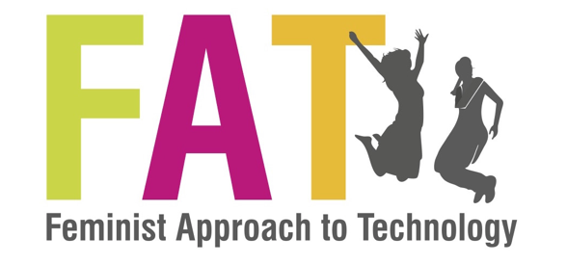**Application Form for:**

**Training cum Assignment Programme on Educators Toolkit on Comprehensive Sexuality Education for Youth with Disabilities**

Name:

Age:

Gender:

Occupation:

Affiliation:

Contact Details:

(Please provide phone number and email ID)

1. Please describe your work with youth with locomotor disabilities. (Word Limit: 300 words)
2. Do you engage with the youths regularly? Please mention the frequency of you contact with the group.
3. Have you received any prior training on Sexual and Reproductive Health Rights (SRHR)? If yes, please mention what training?
4. Do you deliver SRHR programs to youths? If yes, please mention what topics/ methodology you use.
5. Do you face any challenges related to SRHR when you work with youths? If yes, please elaborate.
6. Do you commit to train at least 10 youth with locomotor disabilities between 26th August 2019 and 10th September 2019 using this facilitator’s guide and send us a report as per our format by 12th September 2019?
7. Please attach your updated ( brief) CV, with one person as a reference on your work.

Applicants are requested to send their application to [projects@fat-net.org](mailto:projects@fat-net.org) by no later than 1st August 2019.

Thank you.

Feminist Approach to Technology (FAT)